Economic

# Identify financial benefits

* Describe tangible benefits
  + reduced personnel expenses
  + lower transaction costs
  + higher profit margins
  + Error reduction
  + Increased flexibility
  + Increased speed of activity
  + Improvement of management planning and control
  + Opening new markets and increasing sales opportunities

**TABLE SUGGESTION**

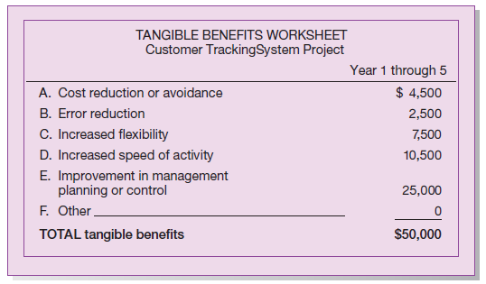

* Describe Intangible benefits
  + improvement of employee morale
  + reduction of waste creation or resource consumption
  + Competitive necessity
  + Timeliness of information
  + Availability of better information
  + Improvement decision making ability
  + Improvement of resource control

# Identify costs

* describe development costs in relation to each phase of the project
* describe the avg hourly cost and work pace of employees based on previous projects
* Describe tangible costs (a cost associated with an information system that can be measured in dollars and with certainty)
  + Cost of labor in relation to each of the development phases:
    - Analysis
    - Planning
    - Design
    - Implementation
  + Operational (employee training)
* Describe intangible costs (a cost associated with an information system that cannot be easily measured in terms of dollars or with certainty)
  + Not many for this project
* Describe possible recurring costs (a cost resulting from the ongoing evolution and use of a system)
  + Application software maintenance
  + Incremental data storage expenses
  + Incremental communications

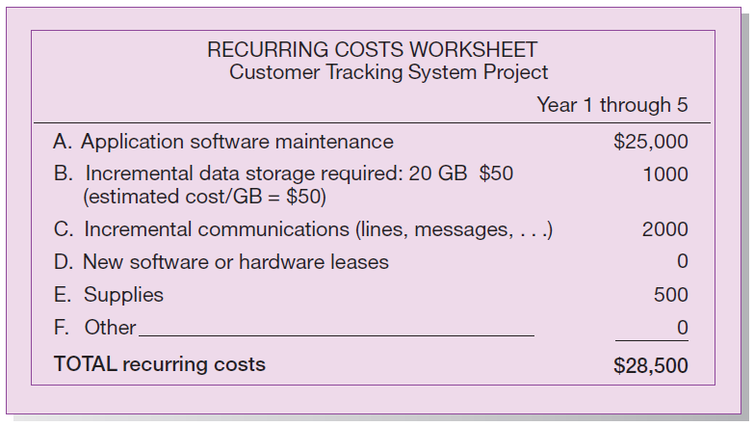

Technical

# Estimate the development organization’s ability to construct the proposed system

* Describe the target hardware (development group’s understanding of the possible target hardware)
* Describe the target software
* Describe the target operating environment
* Describe the system size or complexity
* Describe the company’s experience with developing similar systems
* Describe potential execution risks
  + Size of project (Large projects are riskier than small projects. Relates to the relative project size with which the development group typically works. A “small” project for one development group may be relatively “large” for another)
  + Clarity of requirements (A system in which the requirements are easily obtained and highly structured will be less risky than one in which requirements are messy, ill-structured, ill-defined, or subject to the judgment of an individual)

Contractual

Operational

Scheduling